BLUE DRAGON
Sparkling Water
Lime & Cranberry Flavours

COMPREHENSIVE MARKETING PLAN
MBA — Marketing Management
New Product Launch Strategy
2025

1. Product Idea & Concept

1.1 Product Description
Blue Dragon is a premium, health-forward sparkling water brand targeting India's rapidly expanding wellness beverage segment. The product launches in two exciting natural flavours — Lime and Cranberry — crafted to deliver a bold, refreshing taste experience with zero calories and zero sugar.

Blue Dragon is available in two convenient packaging formats:
- 400ml Slim Aluminium Can — designed for on-the-go consumption, gym-bags, commuters, and impulse purchases at modern retail and quick-service outlets.
- 500ml PET Bottle — suited for home, office, and extended hydration needs; ideal for modern trade shelves, e-commerce, and institutional channels.

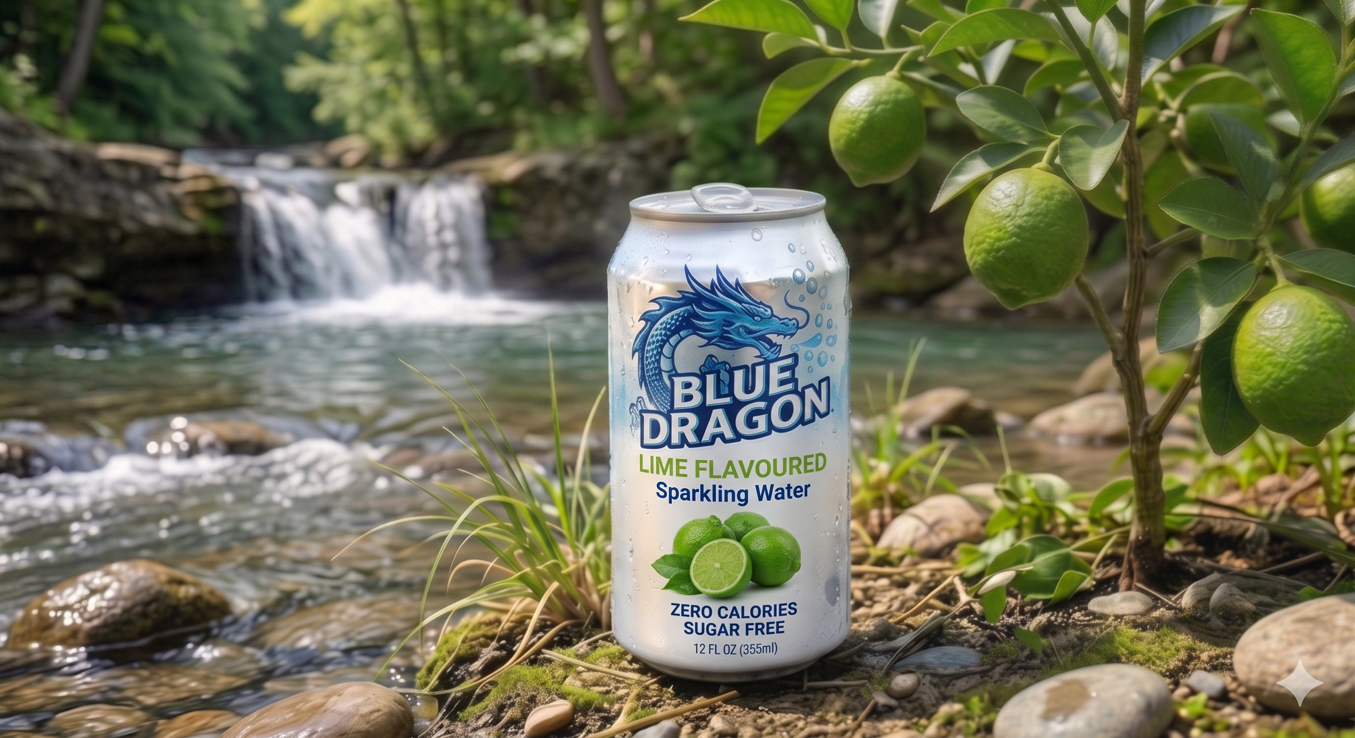
Figure 1: Blue Dragon Lime Flavoured Sparkling Water — 400ml Can
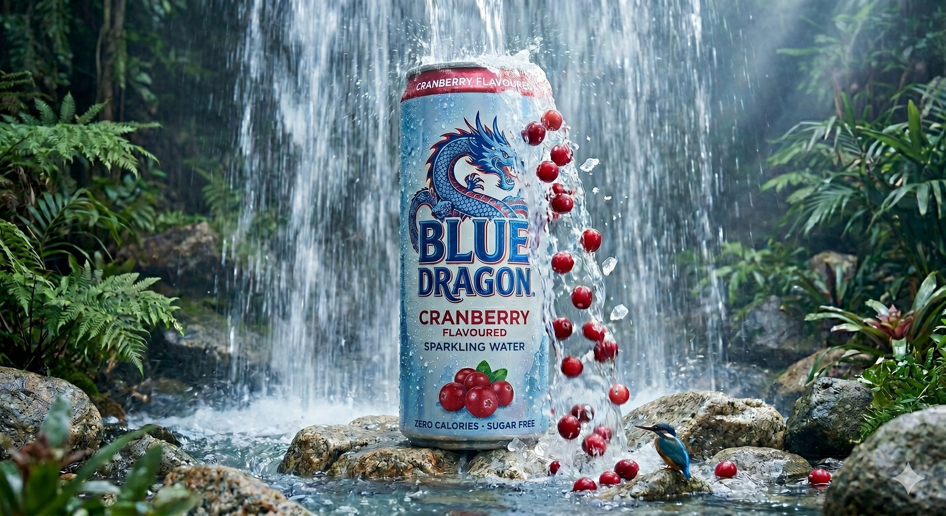
Figure 2: Blue Dragon Cranberry Flavoured Sparkling Water — 400ml Can

1.2 Unique Value Proposition
"Blue Dragon gives you the crisp, refreshing lift of sparkling water infused with bold natural flavours — zero calories, zero sugar, maximum refreshment. A guilt-free escape, every sip."

Key differentiators that make Blue Dragon stand out in the Indian market:
- Zero calories & sugar-free — caters to the growing diabetic-aware and calorie-conscious consumer base.
- Natural fruit flavour infusion — Lime and Cranberry provide exotic, premium taste without artificial sweeteners.
- Dual packaging strategy — 400ml can for premiumisation and 500ml PET bottle for accessibility and value.
- Strong visual identity — The Blue Dragon mascot communicates strength, purity, and natural energy.
- Eco-conscious branding — Aluminium can is 100% recyclable; PET bottle lightweight for lower carbon footprint.

2. Market Analysis

2.1 Target Market
India's non-alcoholic ready-to-drink (RTD) beverage market is experiencing rapid expansion, driven by urbanisation, rising disposable incomes, and a growing health consciousness among millennials and Gen Z consumers. The sparkling water segment is emerging as a premium sub-category within this broader market.

Parameter | Details
Market Size (2024) | ₹3,200 Cr+ (Indian flavoured sparkling water & sparkling beverages)
CAGR (2024–2029) | ~18–22% (Sparkling/functional water sub-segment)
Key Growth Driver | Health-conscious millennials replacing carbonated soft drinks
Primary Geographies | Tier-1 & Tier-2 cities: Mumbai, Delhi, Bengaluru, Hyderabad, Pune, Chennai
Consumption Occasions | Gym, office, dining out, social occasions, travel

2.2 Competitor Analysis
Blue Dragon operates in a competitive landscape dominated by established global and domestic brands. The following competitive matrix benchmarks Blue Dragon against its key rivals:

Competitor | Strengths | Weaknesses
Schweppes (Coca-Cola India) | Strong retail distribution; premium positioning in sparkling mixers and flavoured water | Limited health-forward positioning; high sugar content in mainstream variants; premium price
Paper Boat Sparkling Water | Nostalgic Indian brand with loyal consumer base; unique Indian flavour profiles | Limited international appeal; relatively niche distribution vs. legacy brands
Bisleri Vedica (Sparkling) | Trusted Bisleri parent brand; strong distribution network | Primarily plain sparkling; limited flavour innovation
Evian Sparkling | Premium global positioning; strong urban appeal | Very high price point limits mass penetration; not widely available
Blue Dragon (Our Brand) | Zero cal/sugar; dual-format (can+bottle); bold flavours; strong visual identity; competitive pricing | New entrant; brand awareness to be built from scratch

2.3 Industry Trends
- Post-COVID India has seen a dramatic shift towards low-calorie, sugar-free, and functional beverages. Consumers are actively replacing sugary sodas with healthier alternatives.: Health & Wellness Wave
- Urban Indian consumers are willing to pay a premium for perceived quality — sleek aluminium cans, natural ingredients, and premium branding signal value.: Premiumisation
- Platforms like Blinkit, Zepto, Swiggy Instamart, and Amazon Fresh are driving rapid growth in beverage delivery, enabling new brands to build a national presence quickly.: E-commerce & D2C Growth
- Recyclable packaging and eco-conscious branding are increasingly influencing purchase decisions, especially among younger urban consumers.: Sustainability Focus
- Beyond plain sparkling water, consumers are seeking bold, exotic fruit flavours. Lime and Cranberry are in the sweet spot — familiar enough for broad appeal, distinctive enough for premiumisation.: Flavour Exploration

3. Segmentation, Targeting & Positioning

3.1 Market Segmentation
We have segmented the market across four primary dimensions:

Segment Dimension | Description
Demographic | Age 18–40; Urban professionals, college students, fitness enthusiasts; SEC A & B; Male & Female
Geographic | Metro & Tier-1 cities initially (Mumbai, Delhi, Bengaluru, Hyderabad, Pune); scale to Tier-2 in Year 2
Psychographic | Health-conscious, fitness-oriented, image-aware, social media savvy; values wellness without compromise
Behavioural | Moderate-to-high beverage consumption; frequent on-the-go buyers; brand-loyal once converted; occasion-driven — gym, office, dining, travel

3.2 Target Audience
Primary Target Segment
Urban millennials (22–35 years), working professionals and fitness enthusiasts in metro cities. They are health-aware, calorie-conscious, and willing to pay a premium for quality sugar-free beverages. They are active on Instagram, YouTube, and fitness platforms, and frequently shop via quick-commerce apps.

Secondary Target Segment
Gen Z college students and young adults (18–24 years) who are trend-driven, social-media-influenced, and look for cool, aesthetically appealing beverage options to share online. They are value-sensitive but aspirational.

Tertiary Target Segment
Health-conscious parents (35–50 years) seeking sugar-free alternatives for family consumption; diabetics and calorie-restricted consumers looking for a flavourful yet guilt-free beverage option.

3.3 Positioning Statement
For health-conscious urban Indians aged 18–40 who refuse to compromise on taste or wellness, Blue Dragon Sparkling Water is the premium zero-calorie, sugar-free flavoured sparkling water that delivers bold, refreshing natural fruit flavours — because staying healthy should feel like a reward, not a sacrifice.

Positioning Strategy: Blue Dragon will occupy the Premium Health & Refreshment quadrant — positioned above mass market sparkling waters on quality/taste, and more accessible than ultra-premium imported brands on price. This positioning is reinforced through the bold dragon mascot (energy, strength), natural flavour messaging, and slim-can premium aesthetics.

4. Marketing Mix (4Ps)

4.1 Product
Core Product Features
- Flavours: Lime (refreshing & citrusy) and Cranberry (bold & tangy) — both zero calories, sugar-free, no artificial sweeteners.
- Carbonation Level: Medium carbonation — pleasant fizz without being overwhelming.
- Ingredients: Carbonated water, natural flavour concentrate, citric acid, permitted preservatives. No added sugar, no artificial colours.
- Certifications: FSSAI certified; exploring Vegan & Gluten-Free certification.

Packaging Formats
Format | Details
400ml Aluminium Can | Slim, premium can. Blue-silver gradient design with Blue Dragon mascot. Tab-top easy-open lid. 100% recyclable. Single-serve, chiller-ready.
500ml PET Bottle | Lightweight, resealable screw-cap bottle. Blue Dragon branding with flavour-coded accent colour (Green for Lime, Red for Cranberry). BPA-free, food-safe PET.

Packaging Visual Identity
- Primary colour: Cool steel blue (metallic aluminium base) — communicates purity, freshness.
- Logo: Blue Dragon mascot with water bubble motifs — energy, natural flow.
- Flavour differentiation: Lime — lime green accent; Cranberry — deep red accent.
- On-pack claims: 'Zero Calories', 'Sugar Free', 'Natural Flavour' prominently displayed.

4.2 Pricing Strategy
Blue Dragon adopts a Value-Based Premium Pricing strategy — positioned above mass-market alternatives like Paper Boat Sparkling but below ultra-premium imports, making it aspirational yet accessible.

SKU | Price Point
400ml Can (MRP) | ₹60 – ₹70
500ml PET Bottle (MRP) | ₹50 – ₹60
Multipack — 6-Can Pack | ₹330 (10% discount vs. individual)
Multipack — 12-Bottle Pack | ₹540 (10% discount vs. individual)
Institutional / HoReCa | ₹45–55 per unit (volume-based negotiated pricing)

Pricing Rationale
- 400ml Can at ₹60–70 aligns with premium RTD beverages and café-style positioning.
- 500ml PET Bottle at ₹50–60 is competitively priced vs. Paper Boat (₹40–50) with a premium appeal.
- Introductory launch pricing: 15–20% below target MRP in Month 1 to drive trial and adoption.

4.3 Distribution Plan
Channel Strategy — Phased Rollout
Phase | Channels
Phase 1 (Months 1–6) | Modern Trade: D-Mart, Reliance Smart, Big Bazaar, Spencer's. Quick Commerce: Blinkit, Zepto, Swiggy Instamart. Direct E-commerce: Amazon, Flipkart, own D2C website.
Phase 2 (Months 7–12) | General Trade: Kirana stores, medical stores, departmental stores in metro areas. HoReCa: Gyms, cafes, restaurants, hotels, co-working spaces, corporate canteens.
Phase 3 (Year 2) | Pan-India expansion to Tier-2 cities. Vending machines in airports, metro stations, corporate parks.

Cold Chain & Visibility
- Branded chillers/coolers deployed in key retail outlets for can visibility and chilled availability.
- Eye-level shelf placement negotiated via trade deals in modern retail.
- Strong last-mile partnership with regional distributors for quick GTM in each city.

4.4 Promotion Plan
Above-the-Line (ATL)
- Digital OTT Pre-roll Ads: 15-second impactful ads on Hotstar, YouTube targeting health/fitness content viewers.
- Out-of-Home (OOH): Billboard and digital display campaigns in high-footfall areas — gyms, malls, metro stations, airports.
- Print: Health/lifestyle magazine placements in publications like Health & Nutrition, Vogue India, GQ.

Below-the-Line (BTL)
- In-store sampling activations at modern trade chains — free tasting to drive trial.
- Gym & Fitness Centre partnerships — branded coolers, sponsorship of fitness events.
- Corporate gifting packs for Diwali, New Year — premium multipack gift boxes targeting corporates.
- Restaurant table card placements and QR-linked promotions for dine-in audiences.

Launch Campaign
Campaign Concept: "UNLEASH YOUR DRAGON" — Empowering health-conscious Indians to break free from sugary beverages and embrace bold, guilt-free refreshment. The Blue Dragon symbolises inner strength and the boldness of making the healthy choice.

5. Digital Marketing Plan

5.1 Social Media Strategy
Platform | Strategy
Instagram | Hero platform. Reels showcasing refreshing pour shots, lifestyle content (gym, travel, office). Stories with polls, countdowns, giveaways. Target: 50K followers in 6 months. Weekly posting cadence: 4–5 posts/week.
YouTube | 15–30 sec pre-roll ads. 2-minute brand story film (origin of Blue Dragon concept). Recipe/cocktail mixer content (mocktails using Blue Dragon). Monthly long-form content.
LinkedIn | B2B targeting for corporate/HoReCa channels. Thought leadership posts on health trends. Corporate gifting promotions. Monthly posting.
Twitter/X | Real-time trending engagement. Contest campaigns (#BlueDragonChallenge). Live event coverage. Daily posting.
YouTube Shorts & Instagram Reels | Short-form viral content: unboxing, flavour reveals, taste challenge videos. UGC reposts to build community.

5.2 Influencer Marketing
A three-tier influencer strategy ensures broad reach and authentic engagement across target segments:

Tier | Profile | Role
Mega Influencers (1M+ followers) | 1–2 fitness/wellness celebrities (e.g., celebrity trainers, Bollywood fitness icons) | Brand awareness & credibility; launch campaign hero posts
Macro Influencers (100K–1M) | 8–10 fitness, nutrition, and lifestyle creators on Instagram/YouTube | Unboxing, taste reviews, day-in-the-life content; recipe videos
Micro Influencers (10K–100K) | 30–50 niche fitness, yoga, health-food creators in Tier-1 cities | Authentic peer recommendation; gym & wellness community outreach; UGC generation

Influencer Budget Allocation
- Mega: ₹15–20 lakhs (1–2 key partnerships)
- Macro: ₹10–12 lakhs (8–10 creators @ ₹1–1.5L each)
- Micro: ₹6–8 lakhs (30–50 creators @ ₹15–25K each + product seeding)

5.3 Online Advertising
Channel | Approach
Google Ads | Search campaigns targeting health-conscious keywords: 'sugar-free sparkling water India', 'zero calorie drinks', 'healthy fizzy drinks'. Display retargeting for website visitors.
Meta Ads (Facebook + Instagram) | Interest-based targeting: fitness, yoga, health food, calorie counting. Lookalike audiences from early purchasers. Carousel ads showcasing both flavours.
YouTube Pre-roll | TrueView in-stream ads on fitness, nutrition, cooking, lifestyle content. Skip-resistant first-5-seconds hook: dragon mascot animation + bold flavour visual.
Quick Commerce Ads | Sponsored listings on Blinkit & Zepto apps — high-intent, last-mile conversion focus.
Amazon Sponsored Products | Keyword targeting for 'sparkling water', 'flavoured water', 'sugar-free drinks' on Amazon India.

6. Budget & Sales Forecast

6.1 Marketing Budget (Year 1)
Budget Head | Amount (INR)
Digital Marketing (Social Media + Ads) | ₹35,00,000
Influencer Marketing | ₹35,00,000
ATL — OOH + OTT + Print | ₹25,00,000
BTL — Sampling, Events, In-store Activation | ₹20,00,000
Brand Identity, Packaging Design & Creatives | ₹10,00,000
PR & Media Relations | ₹8,00,000
Trade Marketing (Retailer Incentives, Chillers) | ₹12,00,000
Research, Analytics & Contingency (10%) | ₹15,00,000
TOTAL YEAR 1 MARKETING BUDGET | ₹1,60,00,000 (~₹1.6 Crore)

6.2 Sales Forecast (Year 1)
Quarter | Volume Target | Revenue Target
Q1 (Launch) | 50,000 units/month | ₹27–30 Lakhs/month
Q2 (Growth) | 1,20,000 units/month | ₹65–70 Lakhs/month
Q3 (Scale) | 2,00,000 units/month | ₹1.1–1.2 Cr/month
Q4 (Festive Peak) | 3,00,000 units/month | ₹1.6–1.7 Cr/month
FY Year 1 Total | ~78 Lakh units (blended) | ₹8–9 Crore

Note: Blended MRP assumed at ~₹58 (mix of 400ml can @ ₹65 and 500ml bottle @ ₹55). Trade margins (22–28%) and distributor margins (8–10%) accounted for in net revenue calculation. Break-even targeted in Month 9–10 of operations.

7. Field Component — Consumer Survey

7.1 Survey Overview
A mini consumer survey was designed to validate the Blue Dragon concept and gauge market receptivity among the target audience. The survey was conducted across 20 respondents in the 18–40 age group in metro cities, comprising urban professionals, students, and fitness enthusiasts.

Parameter | Details
Survey Method | Online + In-person structured questionnaire
Sample Size | 20 respondents
Demographics | Age 18–40; Mix of students & working professionals; Metro cities
Key Focus Areas | Purchase intent, flavour preference, price sensitivity, health positioning

7.2 Key Survey Findings
Survey Question | Results
Awareness of sparkling water | 25% drink regularly (4+ times/week); 5% occasionally; 40% rarely; 35% never (n=20)
Preference for sugar-free | 50% would switch (“Yes, definitely” 15% + “Yes, if it tastes good” 35%); 35% “Maybe”; 15% “No”
Flavour preference | Lime: 25% | Peach: 20% | Original Sparkling: 20% | Cranberry: 15% | Raw Mango: 10% | Kokum-Ginger: 10%  Raw Mango (Kachi Kairi): 10% | Kokum-Ginger: 1% | Raw Mango: 9% | Original Sparkling: 5%
Price sensitivity (400ml can) | 55% comfortable at ₹30–50; 25% at ₹50–70; 20% at ₹70–90
Purchase intent for Blue Dragon | 65% ‘Very appealing/Would share on social media’; 10% ‘Looks premium’; 20% ‘It’s okay’; 5% ‘Not really’
Primary purchase channel | Quick Commerce (35%) | Supermarkets/Modern Retail (30%) | Online Marketplaces (20%) | Kirana (10%) | Gyms/Cafes (5%)
Key purchase driver | Health/Carbonation concerns (35%) | Price/Too expensive (35%) | Taste too plain (10%) | Too artificial (10%) | Availability (10%)

7.3 Survey Insights & Implications
- Brand appeal is strong — 75% find Blue Dragon “very appealing” or “premium and interesting,” validating the visual identity. 50% would switch to sparkling water (definitely/if tastes good), confirming meaningful market opportunity.
- Lime remains the top flavour (25%), but Peach and Original Sparkling each command 20% — suggesting an expanded flavour portfolio beyond Lime and Cranberry may accelerate adoption.
- Quick Commerce leads preferred purchase channel (35%), followed closely by Supermarkets/Modern Retail (30%) — Blinkit and Zepto deserve priority listing alongside strong modern trade presence.
- Price sensitivity is the #1 barrier — 55% prefer ₹30–50 pricing, suggesting introductory pricing below current MRP targets will be critical for trial. Simultaneously, health concerns around carbonation (35%) need to be addressed proactively in brand communication.

8. Presentation & Creativity

8.1 Brand Identity & Visual Concept
The Blue Dragon brand identity is built on four creative pillars: Boldness, Purity, Natural Energy, and Premium Refreshment. Every visual element communicates this brand promise.

Element | Description
Brand Name | Blue Dragon — evokes power, natural energy, and mythical freshness
Logo | Hand-crafted blue dragon in water-bubble motif — dynamic, memorable, scalable across packaging
Colour Palette | Steel Blue (primary) + Lime Green / Cranberry Red (flavour accents) + White (clean, pure)
Typography | Bold sans-serif for the brand name (authority); clean modern font for body text (clarity)
Photography Style | Nature settings — waterfalls, forests, rivers — linking brand to natural freshness & purity
Tagline | "UNLEASH YOUR DRAGON" — Empowering consumers to embrace bold, healthy choices

8.2 Prototype & Packaging Showcase
The visual prototypes below demonstrate the complete brand execution across both flavour variants of the 400ml aluminium can format. Each design maintains consistent brand identity while clearly differentiating between the Lime and Cranberry variants through colour coding and fruit imagery.


Prototype 1: Blue Dragon Lime Flavoured Sparkling Water — 400ml Can


Prototype 2: Blue Dragon Cranberry Flavoured Sparkling Water — 400ml Can

Appendix — Quick Reference Summary
Parameter | Blue Dragon
Brand Name | Blue Dragon Sparkling Water
Flavours | Lime | Cranberry
Formats | 400ml Aluminium Can | 500ml PET Bottle
Price Points | Can: ₹60–70 | Bottle: ₹50–60
Target Consumer | Urban Indians, 18–40 years, health-conscious
Key Competitors | Schweppes, Paper Boat Sparkling, Bisleri Vedica
Positioning | Premium Zero-Calorie Flavoured Sparkling Water
Year 1 Marketing Budget | ₹1.6 Crore
Year 1 Revenue Target | ₹8–9 Crore
Launch Markets | Mumbai, Delhi, Bengaluru, Hyderabad, Pune
Hero Campaign | "UNLEASH YOUR DRAGON"
Purchase Intent (Survey) | 70% positive among target audience

